**A Report on**

**COLLEGE NETWORK**

**A Report Submitted**

**In Partial Fulfilment of the Requirements**

**for the Degree of**

**BACHELOR OF TECHNOLOGY**

**In**

**Computer Science and Engineering**

**By**

**VIVEK KUMAR SUVAM**

**(1901500100113)**

**Under the Supervision of**

Signature Signature

(Name of External Supervisor) (Prof. VIKAS SINGH)

(Network Engineer) (Asst. Professor)

(CISCO) (IILM CET AHL)

**Submitted**

**to**

**Department of Computer Science and Engineering**



**2022-2023**

**DECLARATION**

I the undersigned solemnly declare that the project report **COLLEGE NETWORK** is based on my own work carried out during the internship under the supervision of Prof. **Vikas Singh.**

I assert the statements made and conclusions drawn are an outcome of my work. I further certify that

I. The work contained in the report is original and has been done by me under the general supervision of my supervisor.

II. The work has not been submitted to any other Institution for any other degree/diploma/certificate in this university or any other University of India or abroad.

III. We have followed the guidelines provided by the department in writing the report.

IV. Whenever we have used materials (data, theoretical analysis, and text) from other sources, we have given due credit to them in the text of the report and giving their details in the references.

Vivek Kumar Suavm

(190500100113)

**BONAFIDE CERTIFICATE**



**ACKNOWLEDGEMENT**

I am using this opportunity to express my gratitude to everyone who supported me throughout the course. I am thankful for their aspiring guidance, invaluably constructive criticism and friendly advice during this work. I am sincerely grateful to them for sharing their truthful and illuminating views on a number of issues related to this work.

I express my gratitude to my parents for their blessings.

(Vivek Kumar Suvam)

**TABLE OF CONTENTS**

|  |  |  |
| --- | --- | --- |
| S.No | Topic | Page No |
| 1 | Introduction to Networking | 5 |
| 2 | Tools and Technology | 6 |
| 3 | Theory  3.1 Types of Topology and six types of physical topology  3.2Routers  3.3Hubs and switches  3.4Servers  3.5OSI model  3.6Routing Protocol  3.7Nat Pat | 7-13 |
| 4 | Project Work | 14-21 |
| 5 | References | 22 |

**Introduction**

Networking, also known as computer networking, is the practice of transporting and exchanging data between [nodes](https://www.techtarget.com/searchnetworking/definition/node) over a shared medium in an information system. Networking comprises not only the design, construction and use of a network, but also the management, maintenance and operation of the network infrastructure, software and policies.

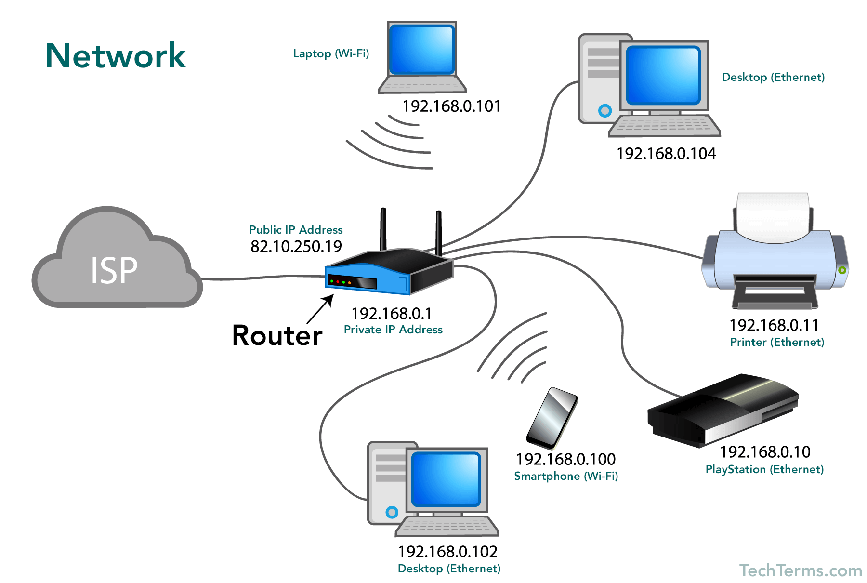Computer networking enables devices and endpoints to be connected to each other on a local area network ([LAN](https://www.techtarget.com/searchnetworking/definition/local-area-network-LAN)) or to a larger network, such as the internet or a private wide area network ([WAN](https://www.techtarget.com/searchnetworking/definition/WAN-wide-area-network)). This is an essential function for service providers, businesses and consumers worldwide to share resources, use or offer services, and communicate. Networking facilitates everything from telephone calls to text messaging to streaming video to the internet of things ([IoT](https://internetofthingsagenda.techtarget.com/definition/Internet-of-Things-IoT)).

## Tools and Technology

**OPERATING SYSTEM**

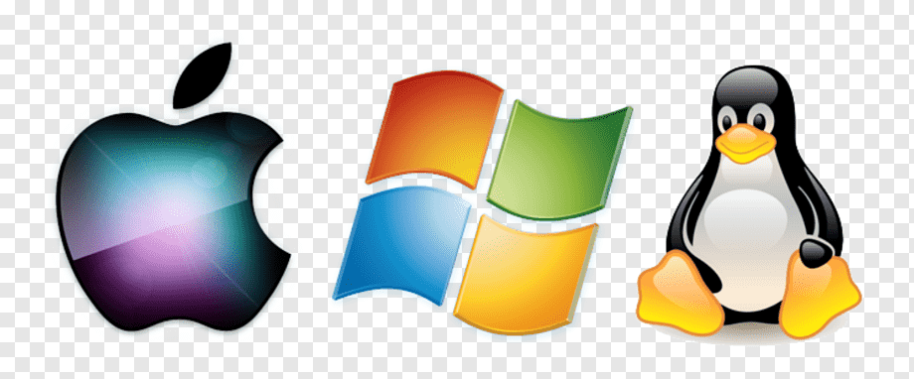An operating system (OS) is the program that, after being initially loaded into the computer by a boot program, manages all of the other application programs in a computer. The application programs make use of the operating system by making requests for services through a defined application program interface (API).

**CISCO PACKET TRACER**

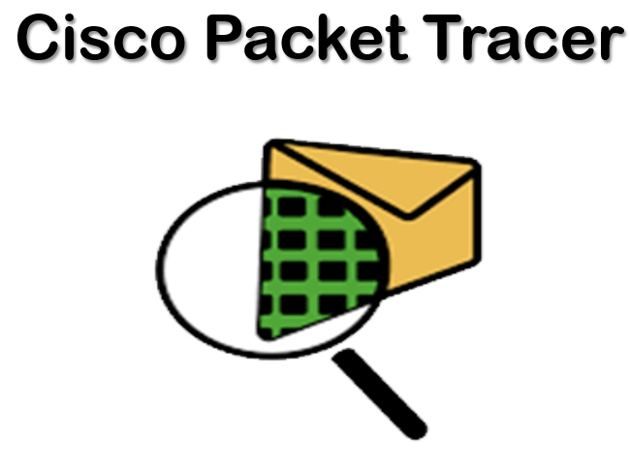Packet Tracer is a cross-platform visual simulation tool designed by Cisco Systems that allows users to create network topologies and imitate modern computer networks. The software allows users to simulate the configuration of Cisco routers and switches using a simulated command line interface.

# Theory

## Types of Topology

1. **Physical Topology:**A physical topology describes the way in which the computers or nodes are connected with each other in a computer network. It is the arrangement of various elements (link, nodes, etc.), including the device location and code installation of a computer network. In other words, we can say that it is the physical layout of nodes, workstations, and cables in the network.
2. **Logical Topology:**A logical topology describes the way, data flow from one computer to another. It is bound to a network protocol and defines how data is moved throughout the network and which path it takes. In other words, it is the way in which the devices communicate internally.

## Six types of physical topology

1. 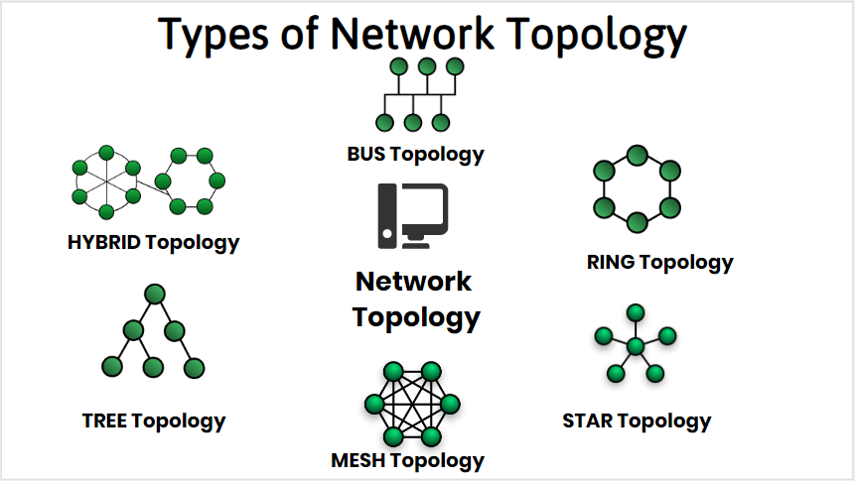Bus Topology
2. Ring Topology
3. Star Topology
4. Mesh Topology
5. Tree Topology
6. Hybrid Topology

## Routers

A router receives and sends data on computer networks. Routers are sometimes confused with network hubs, modems, or network switches. However, routers can combine the functions of these components, and connect with these devices, to improve Internet access or help create business networks.

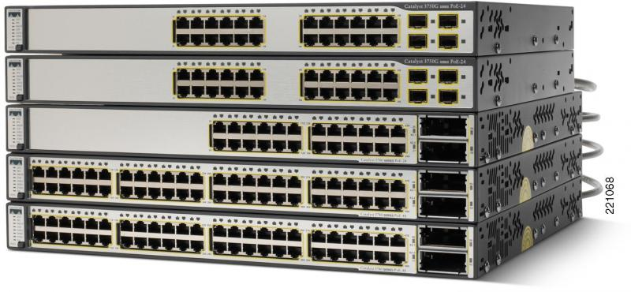

## Hubs & Switches

A network hub is a central connection point for devices in a local area network, or LAN. But there's a limit to the amount of bandwidth users can share on a hub-based network. The more devices are added to the network hub, the longer it takes data to reach its destination. A switch avoids these and other limitations of network hub.

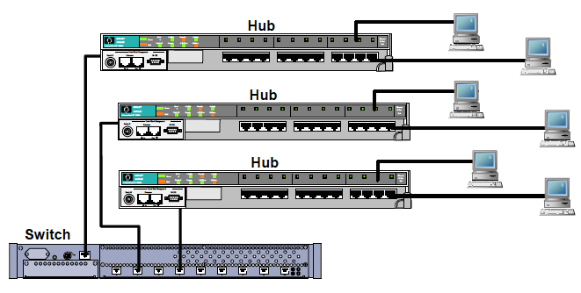

## Servers

A server is a piece of computer hardware or software (computer program) that provides functionality for other programs or devices, called "clients". This architecture is called the client–server model. Servers can provide various functionalities, often called "services", such as sharing data or resources among multiple clients, or performing computation for a client. A single server can serve multiple clients, and a single client can use multiple servers. A client process may run on the same device or may connect over a network to a server on a different device. Typical servers are database servers, file servers, mail servers, print servers, web servers, game servers, and application servers.

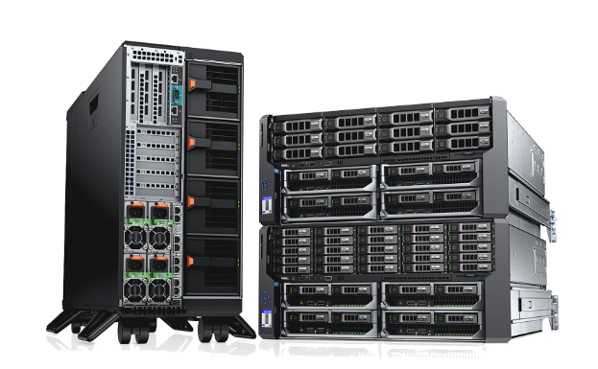

## OSI Model

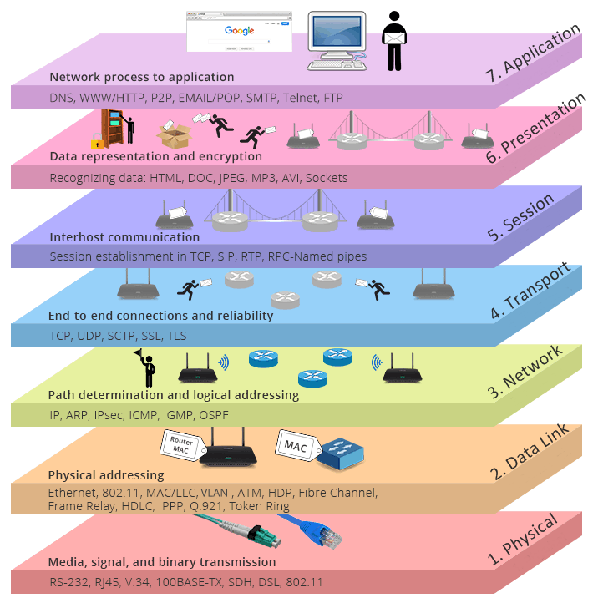The Open Systems Interconnect (OSI) model is a conceptual framework that describes networking or telecommunications systems as seven layers, each with its own function

## Routing protocols

A routing protocol specifies how routers communicate with each other to distribute information that enables them to select routes between nodes on a computer network. Routers perform the traffic directing functions on the Internet; data packets are forwarded through the networks of the internet from router to router until they reach their destination computer. Routing algorithms determine the specific choice of route. Each router has a prior knowledge only of networks attached to it directly. A routing protocol shares this information first among immediate neighbors, and then throughout the network. This way, routers gain knowledge of the topology of the network. The ability of routing protocols to dynamically adjust to changing conditions such as disabled connections and components and route data around obstructions is what gives the Internet its fault tolerance and high availability.

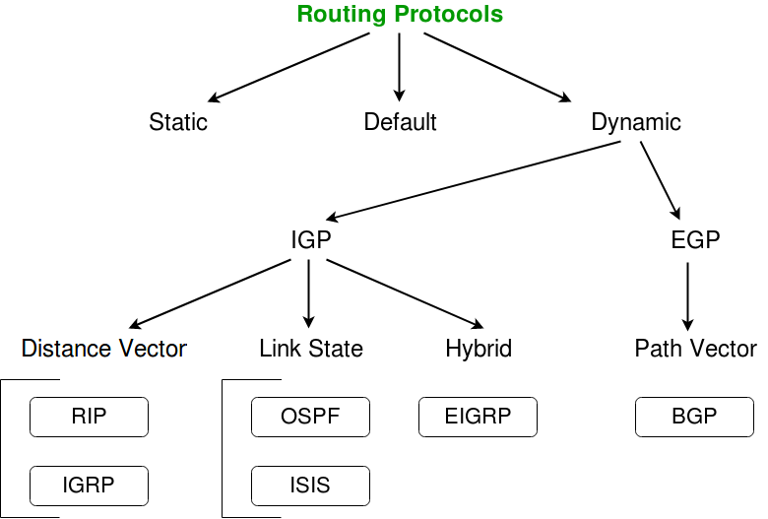

## NAT AND PAT

Port Address Translation (PAT) is an extension of Network Address Translation (NAT) that permits multiple devices on a LAN to be mapped to a single public IP address to conserve IP addresses.

PAT is similar to port forwarding except that an incoming packet with destination port (external port) is translated to a packet different destination port (an internal port). The Internet Service Provider (ISP) assigns a single IP address to the edge device. When a computer logs on to the Internet, this device assigns the client a port number that is appended to the internal IP address, giving the computer a unique IP address.

This module describes how to configure Network Address Translation (NAT) for IP address conservation and how to configure inside and outside source addresses. This module also provides information about the benefits of configuring NAT for IP address conservation.

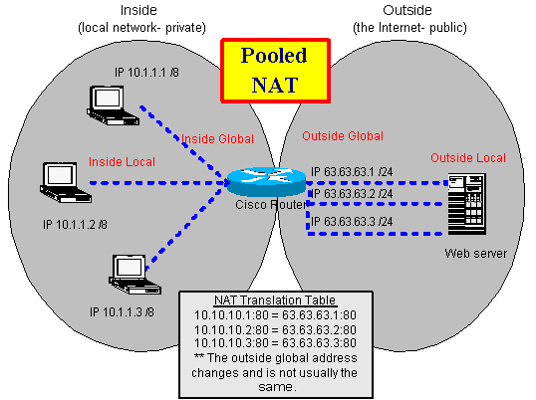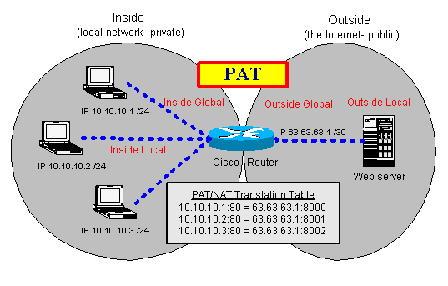

## OSPF & BGP

## While BGP excels with dynamic routing for large networks, OSPF offers more efficient path choice and convergence speed. Border Gateway Protocol, or BGP, and Open Shortest Path First, or OSPF, are two of the most popular, standards-based dynamic routing protocols used around the world.

## What's EIGRP? What's OSPF? EIGRP vs OSPF Differences | FS Community

## BGP and OSPF. How do they interact? | Noction

## PROJECT WORK

**OBJECTIVE**

To build a network for you college campus.

## CONTEXT

College campus network is generally the portion of the enterprise network infrastructure that provides access to network communication services and resources to end users and devices that are spread over a single geographic location.

It specifies whether the design is for a single network segment, a group of LANs, a building or campus network, a group of WAN or remote-access networks, or perhaps the entire campus network.

## Steps and Tasks

## Make a layout of the area where to establish a network.

## Select the devices according to the need in the premises.

## Specific area should have its own main router.

## Each main router should be connected with each other by routing protocols.

## Then provide IP address to the network and subnet according to their users in the premises.

## ROUTER CONFIGURATION COMMANDS

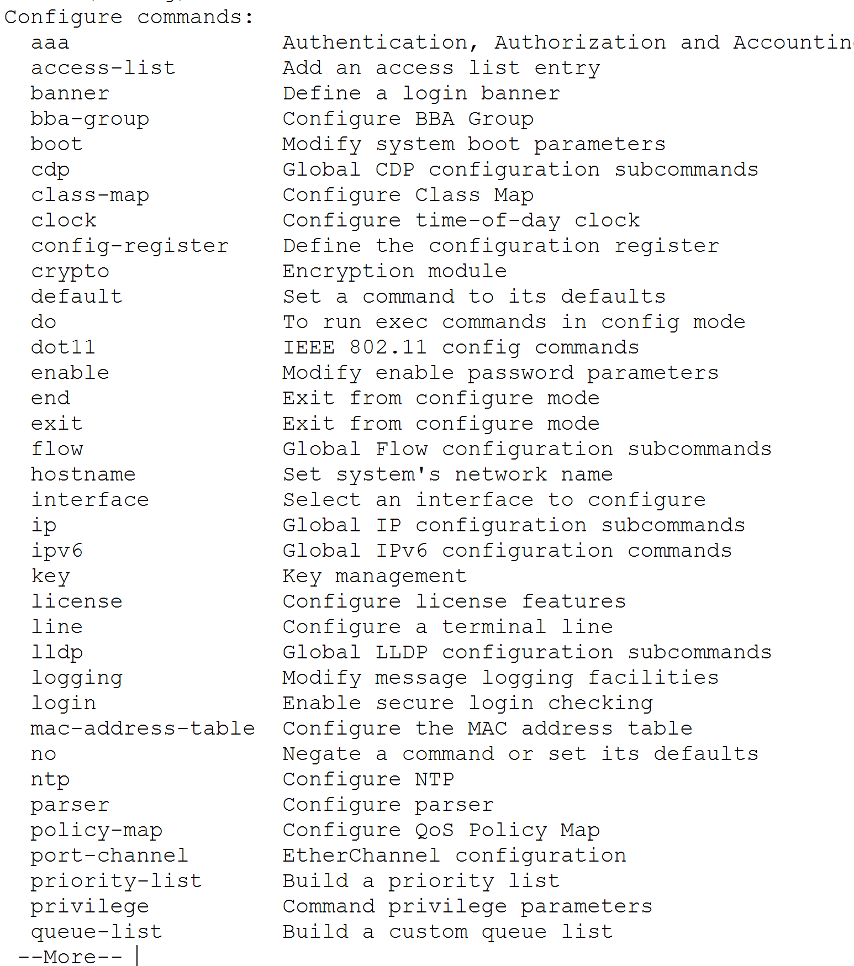

## SWITCH CONFIGURATION COMMANDS

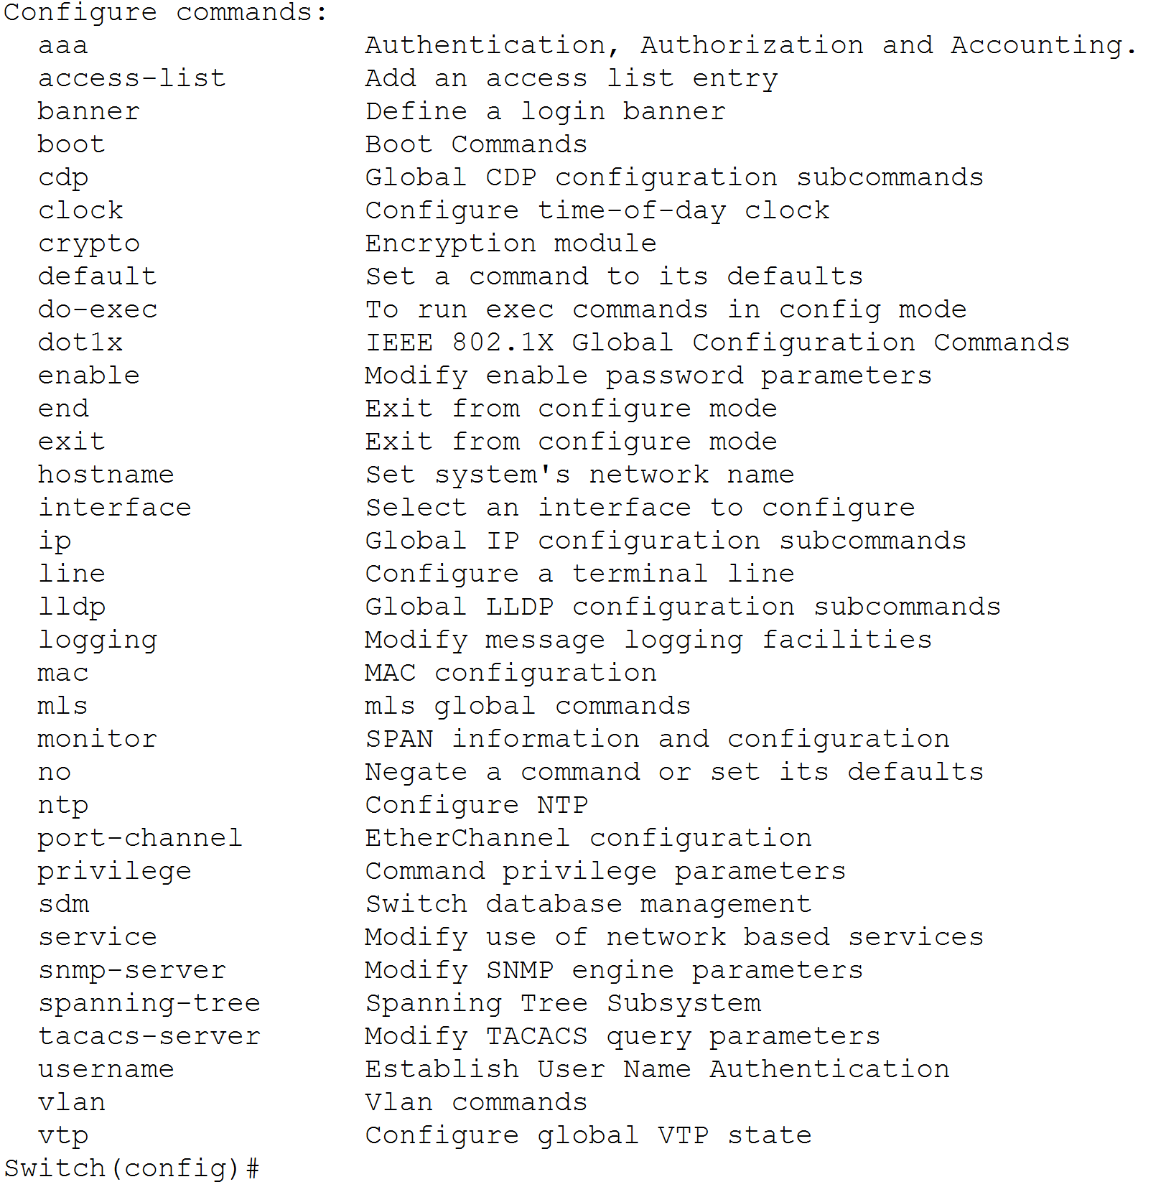

## SOFTWARE USED:-

## OPERATING SYSTEM

## An operating system (OS) is the program that, after being initially loaded into the computer by a boot program, manages all of the other application programs in a computer. The application programs make use of the operating system by making requests for services through a defined application program interface (API).

**CISCO PACKET TRACER**

Packet Tracer is a cross-platform visual simulation tool designed by Cisco Systems that allows users to create network topologies and imitate modern computer networks. The software allows users to simulate the configuration of Cisco routers and switches using a simulated command line interface.

## 

**CAMPUS LAYOUT**

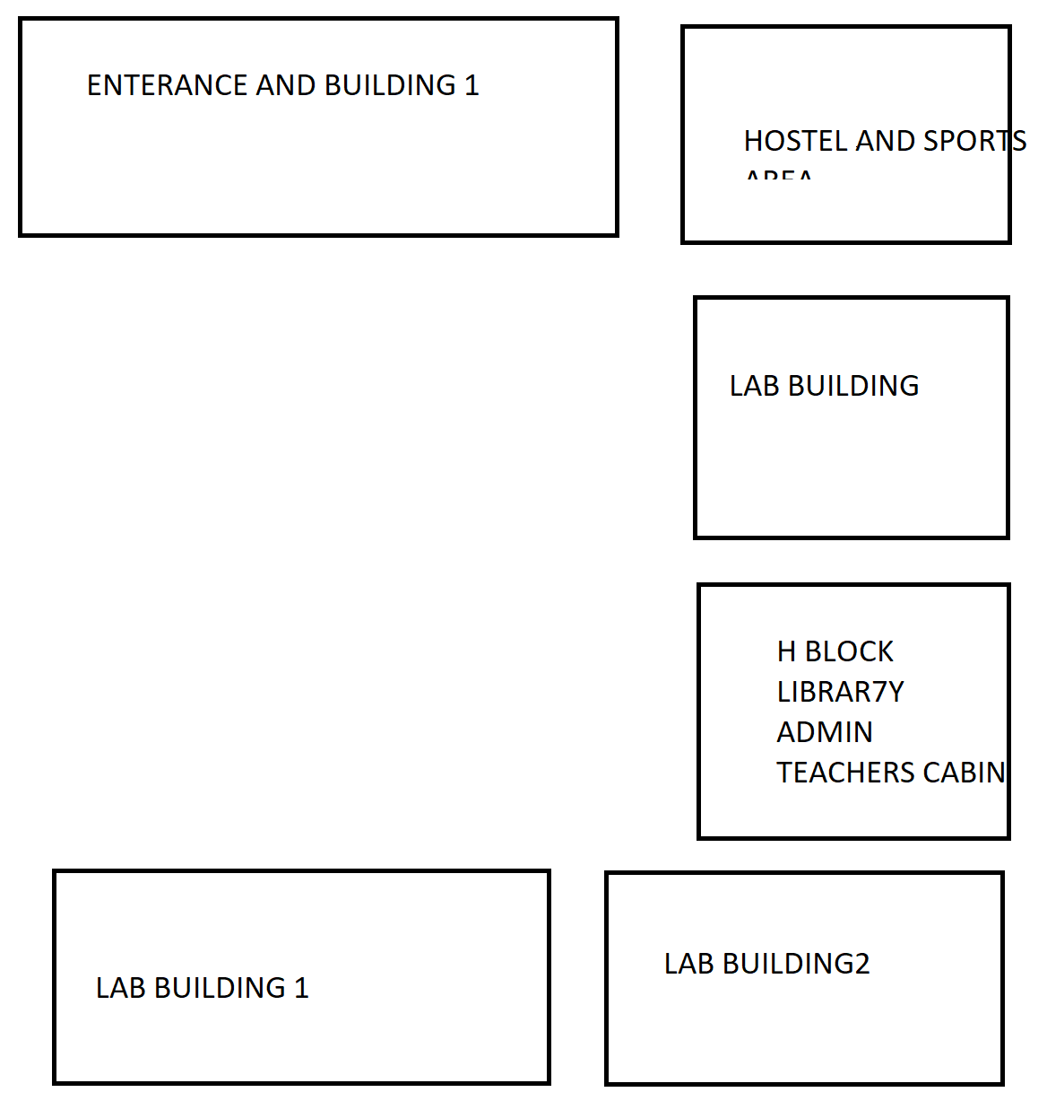

## NO. DEVICES (ARRANGEMENT IN RACKS)

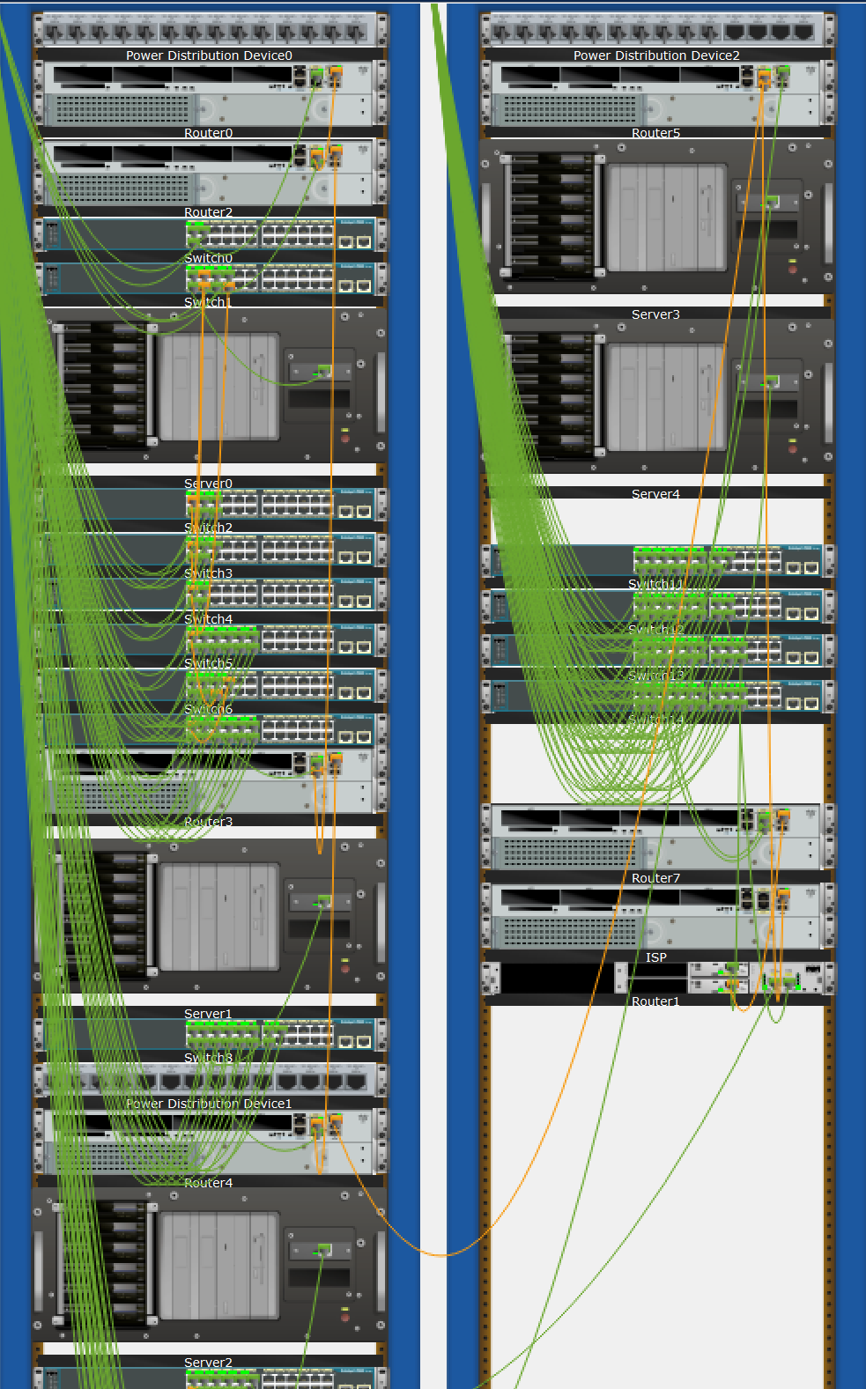

**MAIN ROUTERS**

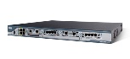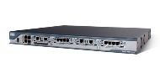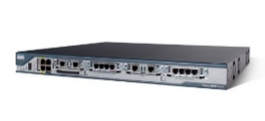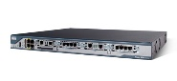

## FINAL LAYOUT AND CONNECTIONS

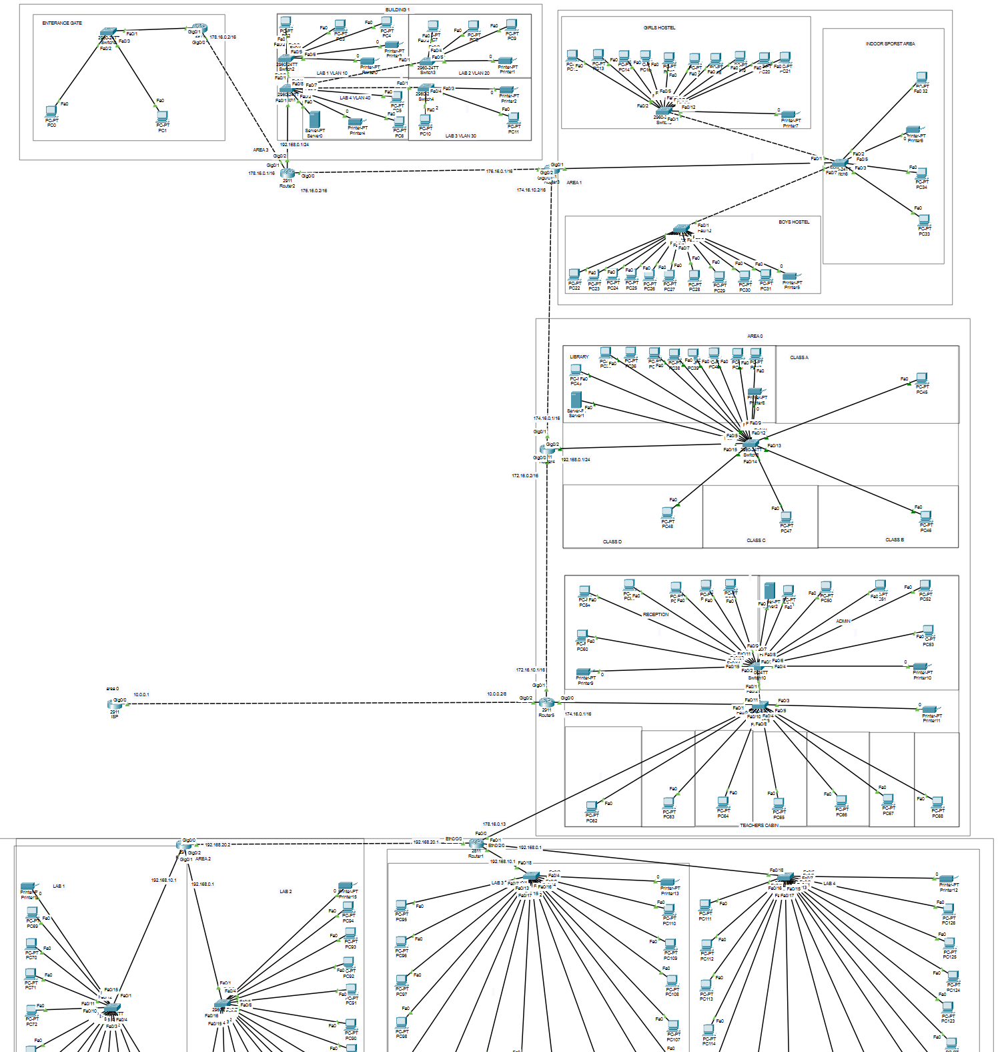

**REFERENCES**

[https://www.netacad.com](https://www.netacad.com/)

<https://www.youtube.com/c/NetworkkingsOrgtraining>

[https://www.emetechnologies.com](https://www.emetechnologies.com/)